**Ict 2 A1Cycle Report**

**Submited by:**

* **Musharraf saeed**
* **MohitKumar Nayak**
* **Ranjeet Kaur**
* **Bhavishaben Patel**

**Submited To:**

* **Laura Antochi**

**Individual Project Role**

1. Musharraf Saeed: Demonstration of running beta release with explanation.
2. Bhavishaben Patel: The burn-down and velocity charts, set-up development/release environment for a new team member.
3. Ranjeet Kaur: Client acceptance agreement and prototype demonstration.
4. Mohit KumarNayak: The Project development and release ICT infrastructure.

**Beta release demonstration of User Stories**

**Logo:**

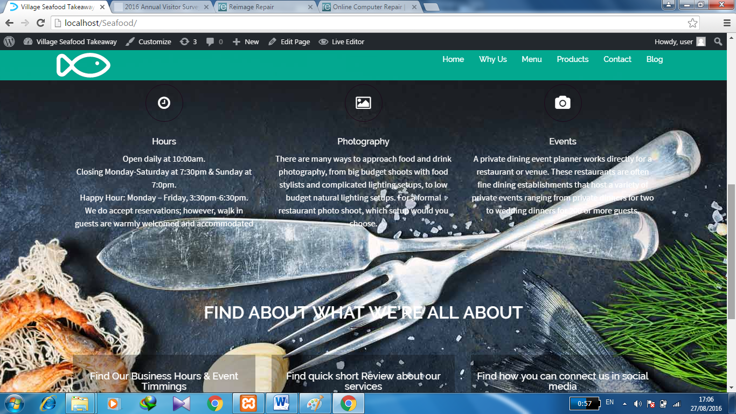

**Modified Home page:**

Here we modified Colors Scheme, pictures and logo and all basic information about shop at home page such as

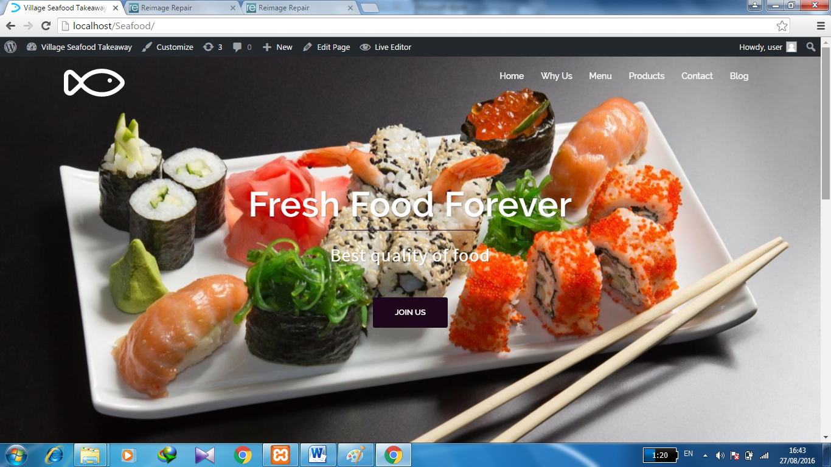



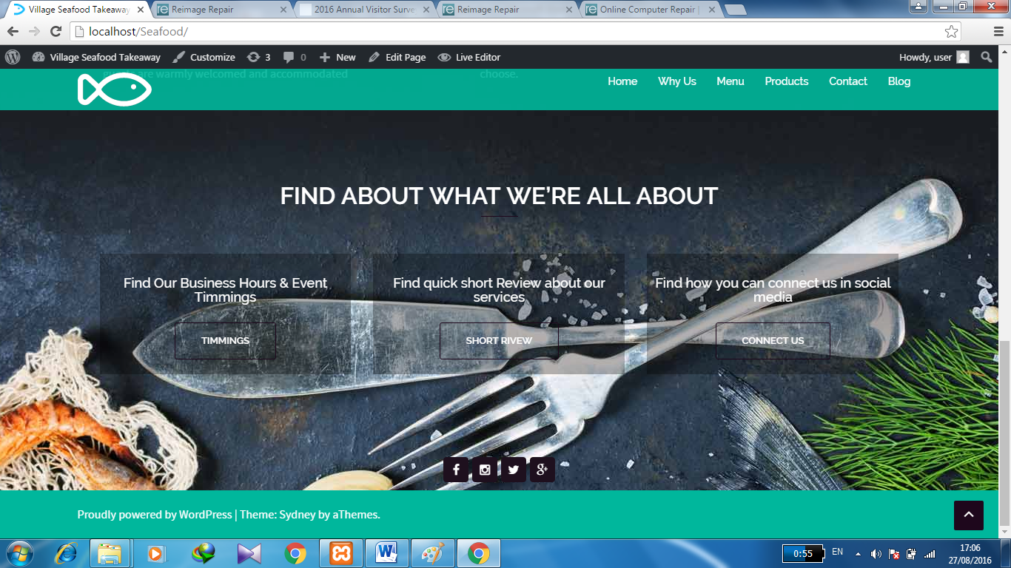

**Modified Contact Us page:**

Feedback form is properly working now and all the information provided in feedback form goes to provided Email address

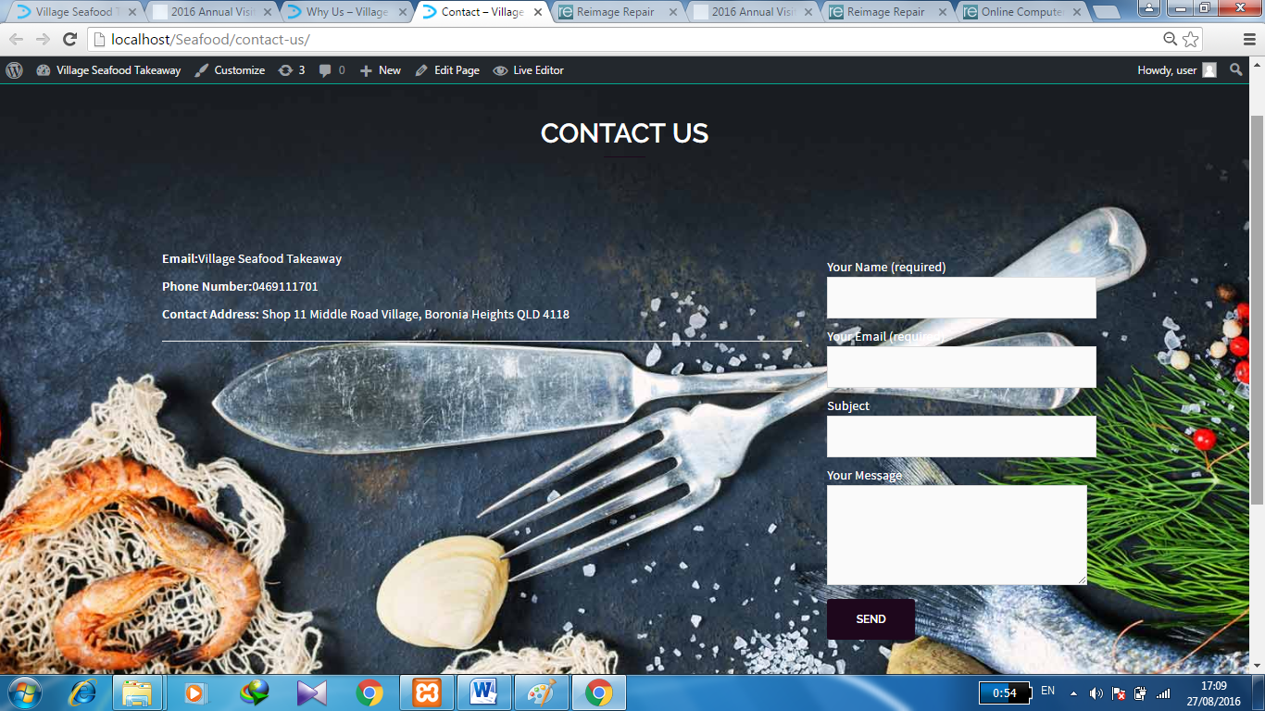

**Menu**

**Milkshakes:**

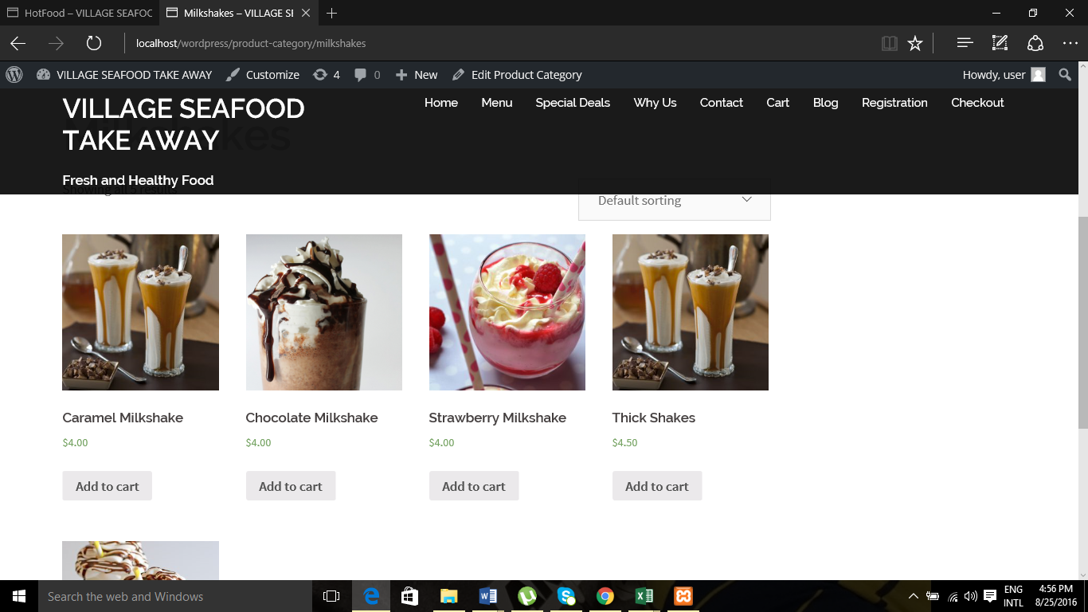

**Burgers:**

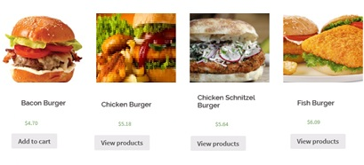

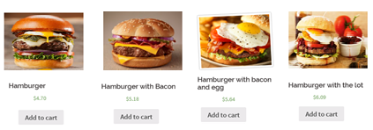

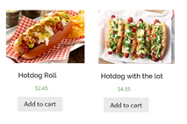

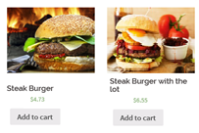

**Hot Food:**

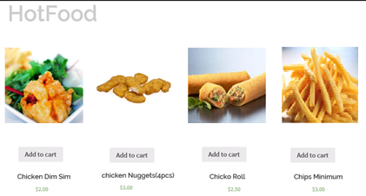

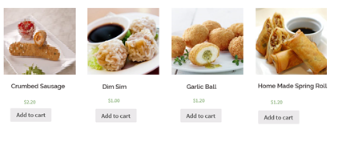

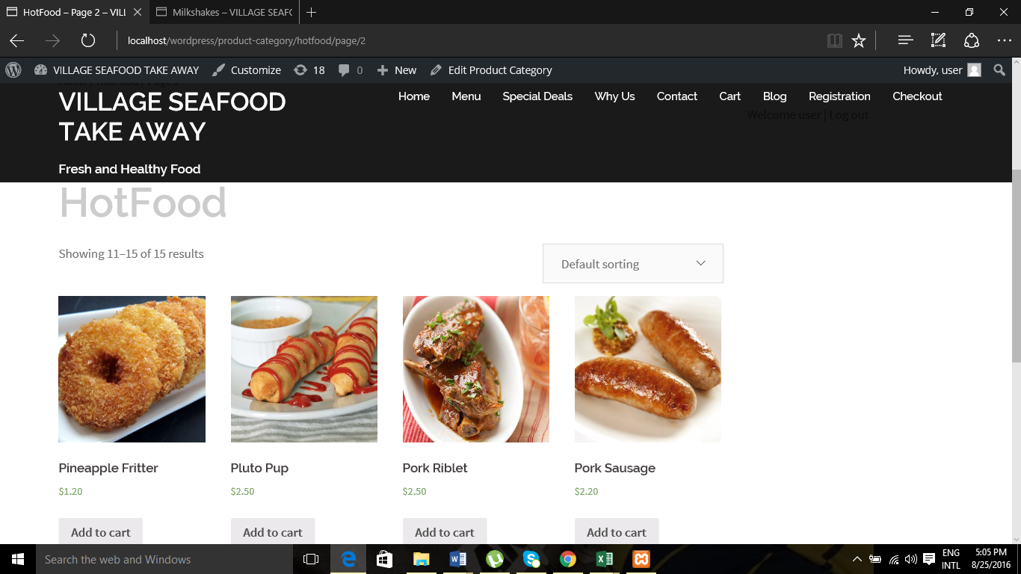

**Seafood:**

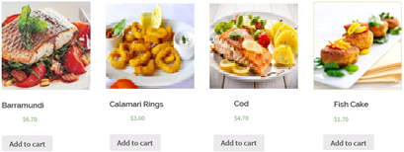

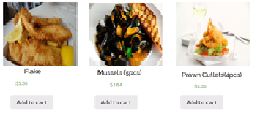

**Cart:**

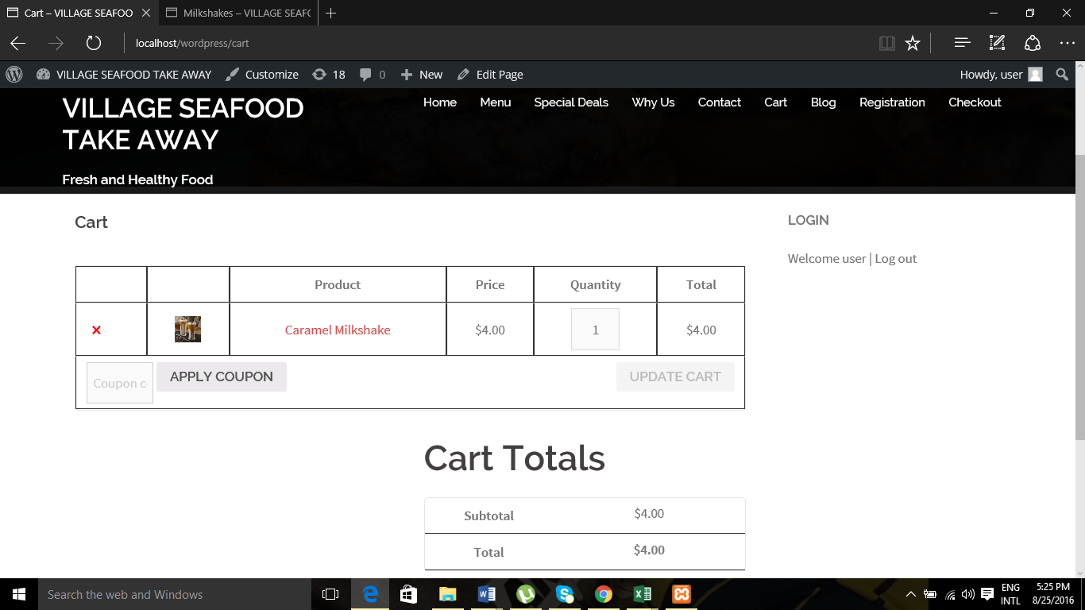

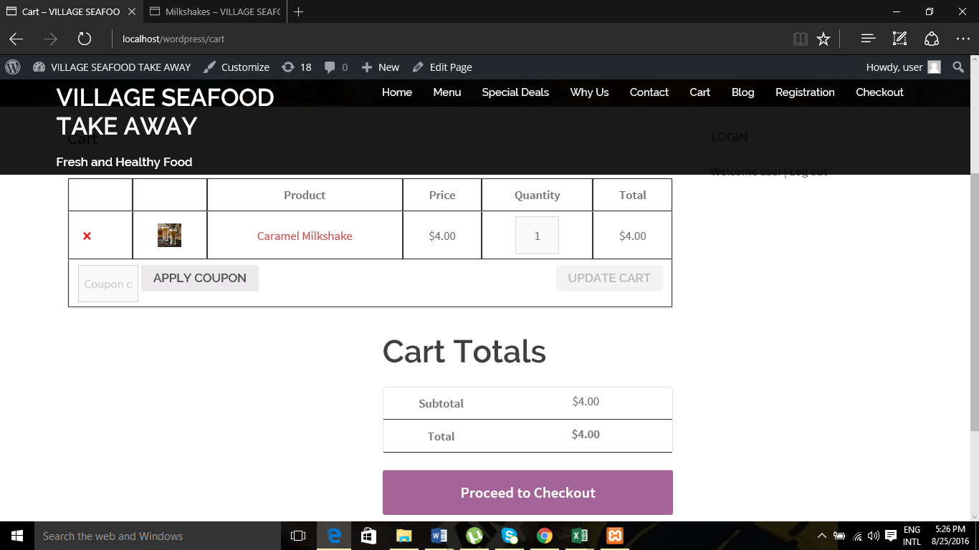

**Checkout**

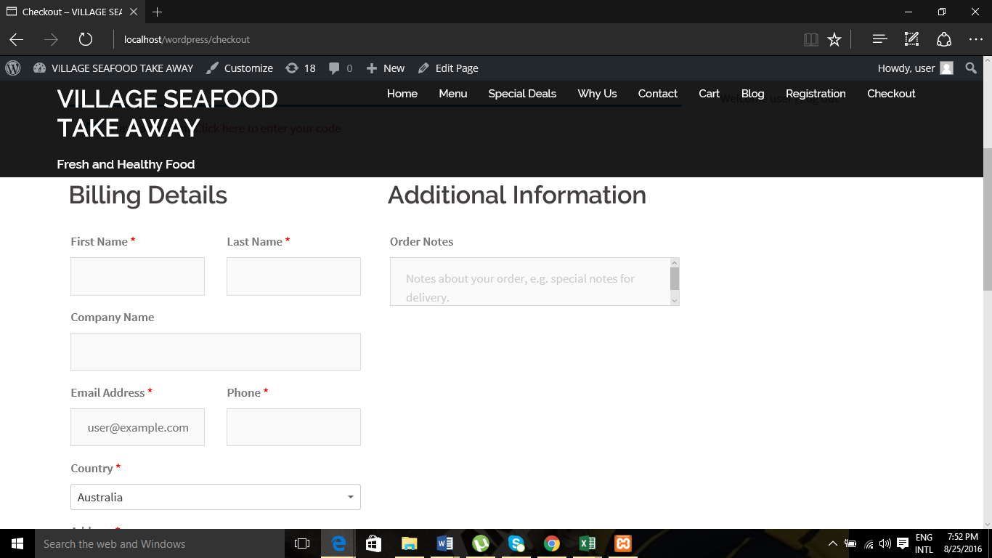

**ICT ADVANCED PROJECT AGREEMENT**

**This Agreement for CP5046 / CP5047 ICT Advanced Project (the “Agreement”) is signed between:**

**Musharraf Saeed, Mohitkumar Nayak, Bhavishaben Abhishek Patel, Ranjeet Kaur (the "Developers")**

**James Cook University Brisbane, 349 Queen Street Brisbane, Queensland**

**AND**

**Middle Road Village Seafood Take Away represented by Ruth Gomes (the "Client")**

**Shop No 11 Middle Road Village Boronia Heights**

**The Agreement governs the rules between the Client and the Developers regarding the project to be developed as academic subject at James Cook University Brisbane.**

1. **PROJECT DESCRIPTION AND GOALS**

**It’s a Seafood Take away shop which is located in Boronia Heights which provides seafood and some other fast food products to the customers with best quality and the owner of seafood want to increase their business by advertising and wants to introduce online order booking to safe the customer timings. Also customer can get discount and know about all the available and upcoming products information products. In this way customer can easily get all the information about shop any time.**

**Finally, our main aim is to provide and satisfy all need which our client wants and produce best result for them.**

1. **DELIVERABLES**

**We have to deliver online working website as well as coding and all the paper works.**

1. **APPROACH TO DEVELOPMENT**

**a) This project has the timeframe between the 14th of March 2016 and 30th of June 2016 to be completed and is subject to the trimester structure corresponding to Study Periods 22 and 23 2016 from James Cook University Brisbane.**

**b) The approach taken for project implementation is dictated by the corresponding Subject Outline and is based on Agile methodologies: The First Iteration will be dedicated to gathering requirements and project planning; the Second Iteration will be dedicated to implementing the highest priority requirements leading to Alpha Release. Similarly, the Third Iteration will lead to Beta release and The Fourth Iteration to the Final release.**

**c) Between releases, the Developers will seek the Client’s feedback on the implemented requirements and will revisit the requirements to be further developed. It is envisaged that the Client will give timely feedback on the Developers’ work and will allow the necessary time for meetings and discussions. The Developers and the Client will negotiate on the requirements to be developed considering the time constraint.**

**d) For educational purposes, the Developers might be asked to implement a series of requirements that the Client does not need. In this case, the Developers will remove these features from the project releases that will be delivered to the Client.**

**e) Project release data and content (for example content of About us, FAQ, Policy, Disclaimer etc) is to be provided by the Client and it is not part of the development process. The Developers can contribute with data and content for testing purposes.**

**f) The developing environment is to be configured by the Developers using resources provided by James Cook University Brisbane. If the implementation requires the use of software which is not freely available, the Client should provide access to it.**

**g) The Developers are responsible of code backup for the whole duration of the project. After the project’s termination, operations such as backup, updates or content changes are the responsibility of the Client.**

**h) For marking purposes only, the Developers will submit copies of the Project Source Code after each release.**

1. **TIMELINE AND PROJECT REQUIREMENTS**



1. **BUDGET**

**a) The deliverables are offered free of charge by the James Cook University Brisbane to the Client through the work of the Developers. The Client may request the implementation of requirements that are excluded from the list above, but this is subject to payment as further negotiated.**

**b) Any third party resources which are not freely available, such as templates, images, SSL certificates, licenses, etc are to be purchased and delivered by the Client.**

1. **INTELLECTUAL PROPERTY**

**a) Any idea or deliverable emerged during the implementation of this project becomes Intellectual Property of the Client. This applies to all development iterations.**

**b) Third party resources used (templates, themes, Google Maps etc.) are subject to the Terms and Conditions of their Owner.**

**7. PROJECT COMMENCEMENT**

**This agreement was signed today, 28th July 2016, between the two parties, leading to the project's**

**Commencement:**

**Developers Client**

**Musharaaf saeed**

**Bhavishaben Patel**

** Ranjeet Kaur Ruth Gomes**

**Mohit Kumar Nayak**

**Signature Signature**

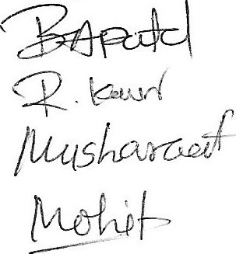

**Burn Down and Velocity Chart**

|  |  |  |  |  |  |  |  |
| --- | --- | --- | --- | --- | --- | --- | --- |
| **Use Stories (Beta)** | **Start** | **Week 5** | **Week 4** | **Week 3** | **Week 2** | **Week 1** | **Total** |
| **Menu** | **6** | **2** | **3** | **1** | **0** | **0** | **6** |
| **Child Theme** | **6** | **3** | **3** | **0** | **0** | **0** | **6** |
| **Additional Links (Home Page)** | **6** | **2** | **3** | **1** | **0** | **0** | **6** |
| **Shooping Cart** | **6** | **3** | **2** | **1** | **0** | **0** | **6** |
| **Colour Scheme** | **6** | **2** | **3** | **1** | **0** | **0** | **6** |
| **Logo** | **5** | **2** | **3** | **0** | **0** | **0** | **5** |
| **Images** | **5** | **2** | **3** | **0** | **0** | **0** | **5** |
|  |  |  |  |  |  |  | **40** |
|  | **start** | **Week 5** | **Week 4** | **Week 3** | **Week 2** | **Week 1** |  |
| **Actual Remaining(Days)** | **40** | **24** | **4** | **0** | **0** | **0** |  |
| **Estimated Reamaining(Days)** | **40** | **16** | **-4** | **-8** | **-8** | **-8** |  |
|  |  |  |  |  |  |  |  |
|  |  |  |  |  |  |  |  |

**The Project development and release ICT infrastructure**

Development environment

1. WordPress: WordPress is a well – known tool for developing website. In our project we develop our website using WordPress. Using WordPress, our team going to develop Seafood take away website for our customers. In this website, we use restaurant based theme, plugins and widget using WordPress which is enhance our website look. After that we use Post and Pages for developing different page and its contents which are very great features of WordPress. Then, also use media files for installing seafood images and files from our desktop. Also we develop menu from menus option which appear in appearance. Then, using setting option we set general setting which may be required for our website. Also, our group share WordPress data through GitHub where we can change coding and that code we use for our website.
2. Plug-in: Plugins increase and enlarge the functionality of WordPress. There are more than 46k plug-ins available in WordPress. Plugins have so many functions and features, so user can easily use it for website (htt2)

**Configuration management:**

**GitHub**

To understand github we need to know about git. It is open source version control framework found in 2008 by Linus Trovalds who find linux. We are going to use github in our project for share files make by group members. We are using repository it’s a location where we can store all our files. As it is version control system we can share any type of file in that. We are using this for sharing our work, so everyone can check who is doing what? It also provides collaboration features, like wikis and some task management tool for our project. (Finley, 2012)

**Programming languages:**

**HTML:**

HTML (Hypertext Markup Language) is the set of markup images or codes inserted in a document proposed for presentation on a World Wide Web program page. This language advises the Web program how to show a Web page's words and pictures for the client. Every markup code is linked to as a component. A few components come in sets that demonstrate when some showcase impact is to start and when it is to end. HTML5 was created to solve the problems which are affecting in HTML4. HTML5 runs flash plugins by itself. (rouse, 2014)

**PHP (HYPERTEXT PREPROSESSOR)**

PHP is a script language and interpreter that we can use it free. It is use for personal home page tools and use primarily on Linux web server. (Rouse, techtarget, 2006)

**CSS:**

It is a programming language in which we can use it for style, size and table for website. (Rouse, techtarget, 2005)

JAVA/JAVASCRIPT:

Java is programming language designed to create complete applications that may run on a single computer and also be used to create applications or applet for web page. (Rouse, 2007)

**How to set-up development environment for a new team member:**

* First of all, we are going to give introduction about whole project.
* We explain, what are the goals and objectives of our project.
* We also need to tell about all user stories what our client need.
* We explain about tools and version control system like WordPress and GitHub. Also, we give this document and report for understanding in detail.
* Also give our team member individual report for understating WordPress, GitHub, Theme and plugin. So After reading this document then our new team member understands about how to login in GitHub and how to install WordPress in PC.
* Then we give short summary about beta release report.

**Prototypes for final release:**

1. Special Deals

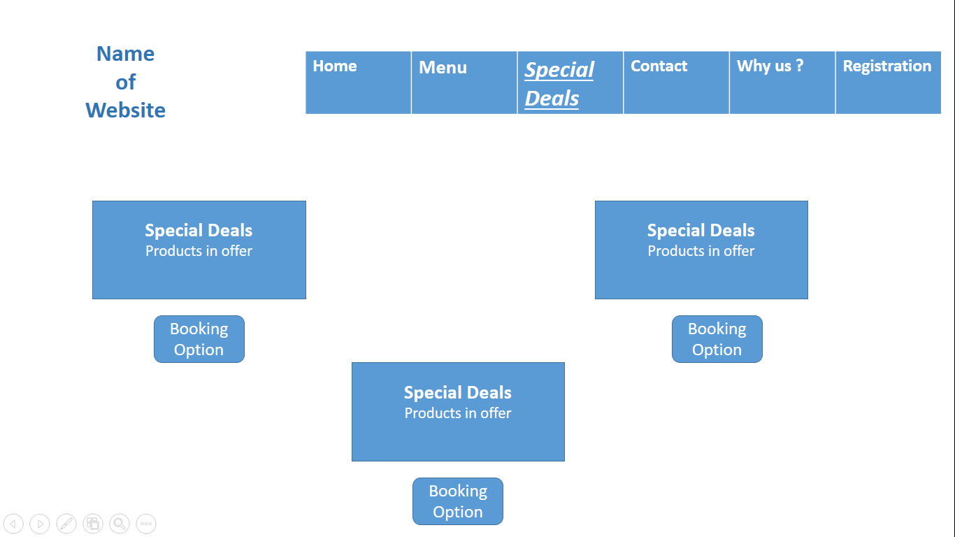

1. SEO



1. Google Analytics

